ECON300 Exam 1
Note: 2 point for each question. Total point is 100.

NAME: ____ ____ ID: __________________

I. Multiple Choices
1. Economists assume that individuals
A) behave in unpredictable ways.
B) will never take actions to help others.
C) prefer to live in a society that values fairness above all else.
D) are rational and respond to incentives.

2. Mr. Peabody chooses to invest in companies that produce goods and services based on consumer preferences. Mr. Peabody is investing in companies that are attempting to be
A) allocatively efficient.
B) productively efficient.
C) guaranteed to make a profit.
D) all of the above

3. Productive efficiency is achieved when
A) firms add a low profit margin to the goods and services they produce.
B) firms produce the goods and services that consumers value most.
C) firms produce goods and services at the lowest cost.
D) there are no shortages or surpluses in the market.

4. Economists reason that the optimal decision is to continue any activity up to the point where the
A) marginal benefit is zero.
B) marginal benefit is greater than the marginal cost.
C) marginal cost is zero.
D) marginal benefit equals the marginal cost.

5. Which of the following statements is true about profit?
A) Profit refers to the revenue received from the sale of a quantity of goods.
B) Profit is calculated by multiplying price and quantity sold.
C) The terms "accounting profit" and "economic profit" can be used interchangeably.
D) Profit is the difference between revenue and cost.

6. Zane's Vanes is a service that restores old weather vanes. Zane has just spent $125 purchasing a 1920s era weather vane which he expects to restore and sell for $500 once the work is completed. After having spent $125, Zane realizes that he will need to spend an additional $200 on materials to complete the restoration. Alternatively, he can sell the weather vane without restoring it for $200. What should he do?
A) He should sell the weather vane now to make the most profit.
B) It does not matter what he does; he is going to take a loss on the project.
C) He should finish the restoration and then sell the weather vane.
D) He should sell the weather vane back to the party he purchased it from and cut his losses.

7. Tabitha shares a flea market booth with her sister. Her share of the rent is $150 per month. She is considering moving to her own, larger booth which she will not have to share with anyone. The larger booth rents for $450 per month. Recently, you ran into Tabitha in the grocery store and she tells you that she has rented the larger booth. Tabitha is as rational as any other person. You rightly conclude that
A) Tabitha did not have a choice; her sister was overcharging her.
B) Tabitha figures that the additional benefit of having her own booth (as opposed to sharing) is at least $300.
C) Tabitha figures that the benefit of having her own booth (as opposed to sharing) is at least $450.
D) the cost of having one's own booth outweighs the benefits.

8. If a demand curve shifts to the right, then
A) demand has increased.
B) quantity demanded has increased.
C) demand has decreased.
D) quantity demanded has decreased.

9. Holding everything else constant, an increase in the price of MP3 players will result in
A) a decrease in the quantity of MP3 players supplied.
B) a decrease in the demand for MP3 players.
C) an increase in the supply of MP3 players.
D) a decrease in the quantity of MP3 players demanded.

10. If the price of automobiles was to increase, then
A) the demand for gasoline would decrease.
B) the demand for gasoline would increase.
C) the supply of gasoline would increase.
D) the quantity demanded of gasoline would decrease.

11. Tom Searchinger, a senior attorney at the Environmental Defense Fund, observed that generous farm subsidies have encouraged farmers to produce more corn and more wheat. How does this affect the market for fertilizer?
A) The supply of fertilizer increases.
B) The supply of fertilizer decreases.
C) The demand for fertilizer increases.
D) The demand for fertilizer decreases.

12. The law of demand implies, holding everything else constant, that as the price of gelato
A) increases, the demand for gelato will increase.
B) increases, the quantity of gelato demanded will increase.
C) decreases, the quantity of gelato demanded will increase.
D) decreases, the demand for gelato will increase.

13. The popularity of digital cameras has enticed large discount stores like Wal-Mart and Costco to offer digital photo printing services. How does this affect the digital photo printing market?
A) The demand curve for digital photo printing services shifts to the right.
B) The demand curve for digital photo printing services shifts to the left.
C) The supply curve for digital photo printing services shifts to the right.
D) The supply curve for digital photo printing services shifts to the left.

14. Assume that the demand curve for MP3 players shifts to the right and the supply curve for MP3 players shift to the left, but the supply curve shifts more than the demand curve. As a result
A) both the equilibrium price and quantity of MP3 players will decrease.
B) the equilibrium price of MP3 players will decrease; the equilibrium quantity will increase.
C) the equilibrium price of MP3 players may increase or decrease; the equilibrium quantity will decrease.
D) the equilibrium price of MP3 players will increase; the equilibrium quantity will decrease.

15. Studies have shown that drinking one glass of red wine per day may help prevent heart disease. Assume this is true, and favorable weather has increased the grape harvest of California vineyards. In the market for red wine, these two developments would
A) increase demand and decrease supply, resulting in an increase in the equilibrium quantity and a decrease in the equilibrium price of red wine.
B) increase demand and increase supply resulting in an increase in the equilibrium quantity and an uncertain effect on the equilibrium price of red wine.
C) increase demand and increase supply, resulting in an increase in the equilibrium price and an uncertain effect on the equilibrium quantity of red wine.
D) increase demand and increase supply, resulting in an increase in both the equilibrium price and the equilibrium quantity of red wine.

16. Which of the following would cause both the equilibrium price and equilibrium quantity of barley (assume that barley is an inferior good) to increase?
A) an increase in consumer income
B) a drought that sharply reduces barley output
C) a decrease in consumer income
D) unusually good weather that results in a bumper crop of barley

17. Which of the following statements is not true?
A) Consumer surplus measures the difference between the highest price a consumer is willing to pay for a product and the price she actually pays.
B) Marginal benefit is the additional benefit to a consumer from consuming one more unit of a product.
C) Consumer surplus measures the net benefit from participating in a market.
D) Producer surplus measures the total benefit received by producers from participating in a market.

18. In a city with rent-controlled apartments, all of the following are true except
A) apartments usually rent for rates lower than the market rate.
B) apartments are often in shorter supply than they would be without rent control.
C) it usually takes more time to find an apartment than it would without rent control.
D) landlords have an incentive to rent more apartments than they would without rent control.

19. Frieda is at her local florist to buy a dozen roses. She is willing to pay $75 for the roses, and buys them for $75. Frieda's consumer surplus from the purchase is
A) $150
B) $75
C) $37.50
D) $0

20. A supply curve shows
A) the quantities sold at different prices.
B) the marginal cost of producing one more unit of a good or service.
C) the marginal benefit from buying one more unit of a good or service.
D) the total cost of producing different quantities of a good or service.

21. The willingness of consumers to buy a product at different prices is shown on a
A) demand curve.
B) supply curve.
C) production possibilities frontier.
D) marginal cost curve.

22. ________ is maximized in a competitive market when marginal benefit equals marginal cost.
A) Deadweight loss
B) Marginal profit
C) Economic surplus
D) Selling price

23. A ________ curve shows the marginal cost of producing one more unit of a good or service.
A) demand
B) supply
C) production possibilities
D) marginal benefit

24. If, in a competitive market, marginal benefit is less than marginal cost
A) the net benefit to consumers from participating in the market is less than the net benefit to producers.
B) the government must force producers to raise prices in order to achieve economic efficiency.
C) the quantity sold is greater than the equilibrium quantity.
D) the quantity sold is less than the equilibrium quantity.

II. Essays
Table 1-5
Hours  Open | Total  Revenue  (dollars) | MC | MB
1 | $40 | 18 | 40
2 | 65 | 18 | 25
3 | 80 | 18 | 15
4 | 90 | 18 | 10
5 | 95 | 18 | 5
6 | 98 | 18 | 3

Julius runs a small tailor shop in the city of Bloomfield. He is debating whether he should extend his hours of operation. Julius figures that his sales revenue will depend on the number of hours the tailor shop is open as shown in the table above. He would have to hire a worker for those hours at a wage rate of $18 per hour.

1. Refer to Table 1-5. Using marginal analysis, determine how many hours should Julius extend his shop's hours of operations?
- 2 hours

2. Refer to Table 1-5. What is Julius's marginal benefit if he decides to stay open for three hours instead of two hours?

- $15

3. Refer to Table 1-5. What is Julius's marginal cost if he decides to stay open for three hours instead of two hours?

- $18

Figure 2-2
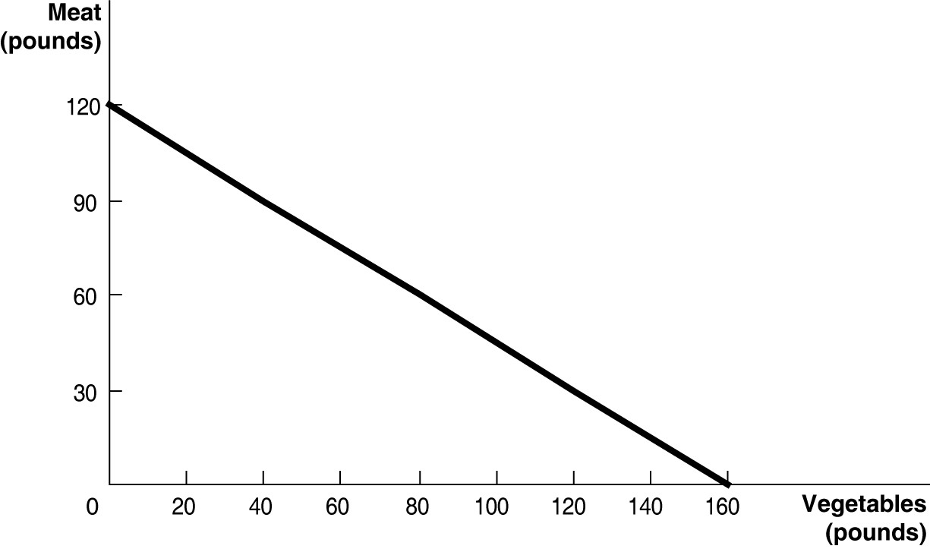
Figure 2-2 above shows the production possibilities frontier for Mendonca, an agrarian nation that produces two goods, meat and vegetables.

4) Refer to Figure 2-2. What is the opportunity cost of one pound of vegetables?

- 120/160= 0.75 pound of meat

5) Refer to Figure 2-2. What is the opportunity cost of one pound of meat?

- 160/120 = 4/3 = 1.33 pounds of vegetables

6) Refer to Figure 2-2. Suppose Mendonca is currently producing 60 pounds of vegetables per period. How much meat is it also producing, assuming that resources are fully utilized?

- 75 pounds of meat

Question on Market Equilibrium. In each of the following three situations, list what will happen to the equilibrium price and the equilibrium quantity for a particular product, which is an inferior good.

7. The number of firms in the market decreases and income decreases
- The equilibrium price will increase. The equilibrium quantity will increase, decrease, or stay the same
8. Consumer preference decreases and the price of a complement increases
- The equilibrium price and equilibrium quantity will decrease
9. The price of a substitute in consumption increases and the price of a substitute in production increases
- The equilibrium price will increase. The equilibrium quantity will increase, decrease, or stay the same
Table 2-9
 | Serena | Haley
Bracelets | 8 | 9
Necklaces | 16 | 12

Table 2-9 shows the output per week of two jewelers, Serena and Haley. They can either devote their time to making bracelets or making necklaces.

10. Refer to Table 2-9. Which of the following statements is true?
A) Haley has an absolute advantage in making both products.
B) Serena has an absolute advantage in making both products.
C) Haley has an absolute advantage in making bracelets and Serena in making necklaces.
D) Haley has an absolute advantage in making necklaces and Serena in making bracelets.

11. Refer to Table 2-9. What is Haley's opportunity cost of making a bracelet?
- 12/9 = 4/3 = 1.33 necklaces

12. Refer to Table 2-9. What is Haley's opportunity cost of making a necklace?
- 9/12 = 0.75 bracelets

13. Refer to Table 2-9. What is Serena's opportunity cost of making a bracelet?
- 16/8 = 2 necklaces

14. Refer to Table 2-9. What is Serena's opportunity cost of making a necklace?
- 8/16 = 0.5 bracelets

15. Refer to Table 2-9. Which of the following statements is true?
A) Haley has a comparative advantage in making both products.
B) Serena has a comparative advantage in making both products.
C) Haley has a comparative advantage in making bracelets and Serena in making necklaces.
D) Haley has a comparative advantage in making necklaces and Serena in making bracelets.

Figure 3-5
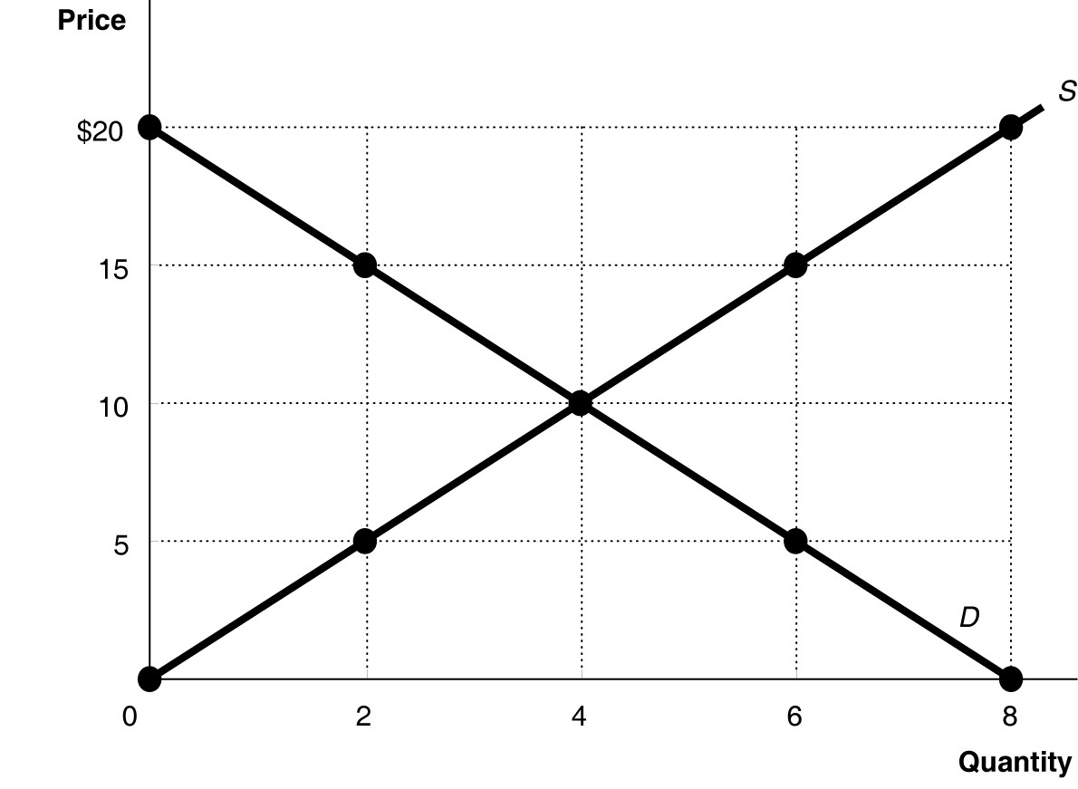
16. Refer to Figure 3-5. At a price of $15, is there shortage or surplus? How much is that shortage or surplus?
- There is surplus of 4 in quantity

17. Refer to Figure 3-5. At a price of $20, is there shortage or surplus? How much is that shortage or surplus?
- There is surplus of 8 in quantity

18. Refer to Figure 3-5. At a price of $10, how much is the quantity sold?
- 4 quantity is sold

19. Refer to Figure 3-5. In a free market such as that depicted above, a surplus is eliminated by
A) a price increase, increasing the supply and decreasing the demand.
B) a price decrease, decreasing the supply and increasing the demand.
C) a price decrease, decreasing the quantity supplied and increasing the quantity demanded.
D) a price increase, increasing the quantity supplied and decreasing the quantity demanded.

20. Refer to Figure 3-5. In a free market such as that depicted above, a shortage is eliminated by
A) a price increase, increasing the supply and decreasing the demand.
B) a price decrease, decreasing the supply and increasing the demand.
C) a price decrease, decreasing the quantity supplied and increasing the quantity demanded.
D) a price increase, increasing the quantity supplied and decreasing the quantity demanded.

Figure 4-7

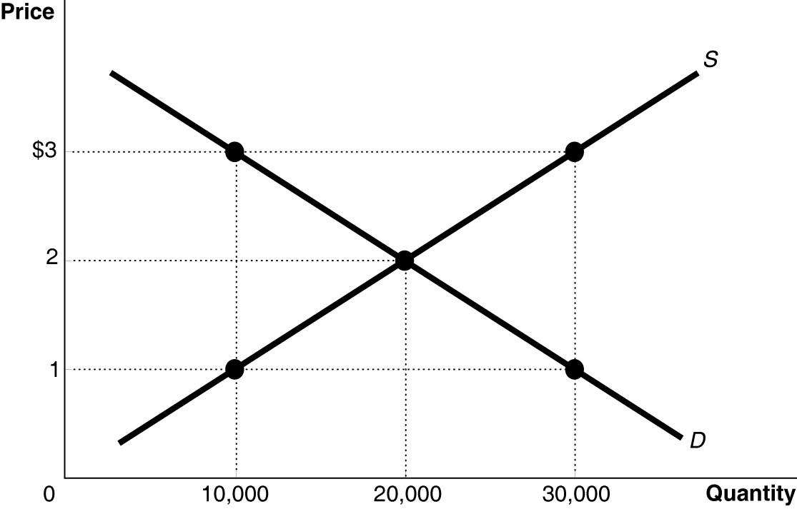

21) Refer to Figure 4-7. The figure above represents the market for iced tea. Assume that this is a competitive market. At an output of 10,000 units
A) the marginal cost of iced tea is greater than the marginal benefit; therefore, output is inefficiently low.
B) producers should lower the price to $1 in order to sell the quantity demanded of 10,000.
C) the marginal benefit of iced tea is greater than the marginal cost; therefore, output is inefficiently low.
D) the marginal benefit of iced tea is greater than the marginal cost; therefore, output is inefficiently high.

22) Refer to Figure 4-7. The figure above represents the market for iced tea. Assume that this is a competitive market. At an output of 30,000 units
A) the marginal cost of iced tea is greater than the marginal benefit; therefore, output is inefficiently high.
B) producers should raise the price to $3 in order to sell the quantity demanded of 30,000.
C) the marginal benefit of iced tea is greater than the marginal cost; therefore, output is inefficiently low.
D) the marginal benefit of iced tea is greater than the marginal cost; therefore, output is inefficiently high.

23) Refer to Figure 4-7. The figure above represents the market for iced tea. Assume that this is a competitive market. If the price of iced tea is $1
A) the quantity supplied is less than the economically efficient quantity.
B) the quantity supplied is economically efficient but the quantity demanded is economically inefficient.
C) economic surplus is maximized.
D) not enough consumers want to buy iced tea.

24) Refer to Figure 4-7. The figure above represents the market for iced tea. Assume that this is a competitive market. If the price of iced tea is $1, what changes in the market would result in an economically efficient output?
A) The price would increase, the quantity supplied would increase, and the quantity demanded would decrease.
B) The quantity supplied would increase, the quantity demanded would decrease, and the equilibrium price would increase.
C) The price would increase, the demand would increase, and the supply would decrease.
D) The price would increase, quantity demanded would increase, and quantity supplied would decrease.

25) Refer to Figure 4-7. The figure above represents the market for iced tea. Assume that this is a competitive market. If 20,000 units of iced tea are sold
A) the deadweight loss is equal to economic surplus.
B) producer surplus equals consumer surplus.
C) the marginal benefit of each of the 20,000 units of iced tea equals $3.
D) marginal benefit is equal to marginal cost.

26) Refer to Figure 4-7. The figure above represents the market for iced tea. Assume that this is a competitive market. If 10,000 units of iced tea are sold
A) the deadweight loss is equal to economic surplus.
B) producer surplus equals consumer surplus.
C) the marginal benefit of each of the 10,000 units of iced tea equals $3.
D) marginal benefit is less than marginal cost.

